**Experiment 3. Photophysical Properties of Pyrene in Solution**

**Objectives:**

1. Explore experimentally a variety of photophysical processes and their effect on absorption and fluorescence spectra.

2. Investigate the formation of “excimers,” or excited-state dimers.

3. Quantitatively describe spectroscopic properties of a sample, such as the molar extinction coefficient and the fluorescence quantum yield.

**Background**: After a molecule absorbs a photon, a number of various pathways can contribute to the molecule’s subsequent relaxation back to its ground state. Photophysics involves the study of such relaxation events. The types of relaxation pathways available depends on the chemical and electronic nature of the molecule and the excited electronic state where it is promoted to during absorption. In general, those transitions are either radiative or non-radiative, meaning a photon will be re-emitted in the relaxation process or it will not. Pyrene (Fig. 1a) is an ideal compound to explore a range of photophysical processes in solution using UV-vis and fluorescence spectroscopy.

The lowest pyrene electronic excitations involves promotion of an electron from a bonding *π* molecular orbital to an antibonding *π\** orbital, or a *π*→ *π*\* transition (Fig. 1b). We denote the first excited state *S*1, where the “*S*” refers to a “singlet” electronic state (i.e. no unpaired spins), and the “1” refers to the first state above the ground state, *S*0. There are a number of higher energy excited states that can be accessed by ultraviolet light, and the particular transition is then chosen by the frequency of the light used to excite pyrene, ν:

Figure 1. (a) Structure of pyrene and (b) frontier molecular orbitals

*Pyrene*(*S*0) + *hν* → *Pyrene\**(*S*1, *S*2, *S*3,…)

Interestingly, the first (meaning lowest energy) electronic transition, *S*0→*S*1, of pyrene is extremely weak and therefore pyrene cannot be promoted directly to that state with light absorption. Therefore in this experiment we will be promoting pyrene to the *second* excited state, *S*0→*S*2, in the near UV region around 340 nm leading to substantial absorption. However, since the *S*1 state is lower energy, it can be accessed via rapid internal conversion (<10-11 s) due to collisions with the solvent:

*Pyrene\**(*S*2) → *Pyrene\**(*S*1)

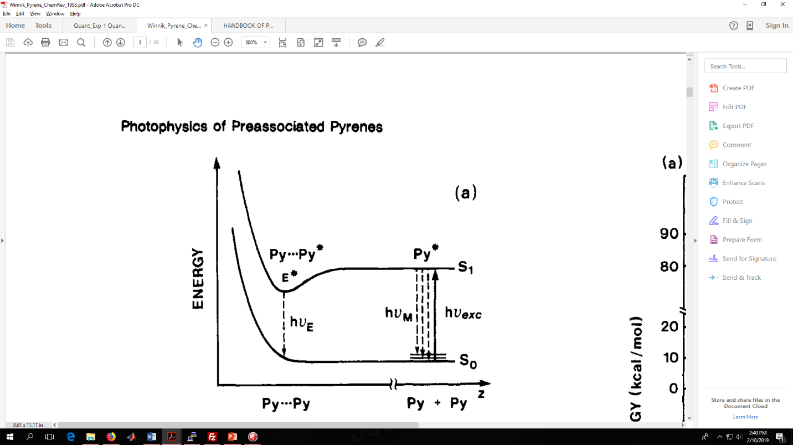The lifetime of an excited state (or how long the molecule resides there before returning to the ground state) is inversely proportional to the absorption strength. Therefore, pyrene will remain in the *S*1 state ~380 ns before finally returning to the ground state by fluorescence. Given this abnormally long-lived excited state, pyrene can diffuse through solution for some time while excited. If the solution is concentrated enough that there is a high probability of the excited pyrene to approach a second ground state pyrene, an excited dimer known as an “excimer” can be formed. While the “excited dimer” forms a stable complex in solution, the ground state dimer does not. This is represented by the potential energy curves of the ground state *pyrene-pyrene* dimer vs. the *pyrene*-pyrene* excimer in Figure 2. Given that the ground state dimer species is unstable, it can be seen in Figure 2 that emission from the excimer will promote the complex down to a repulsive part of the ground state potential energy that is completely “unbound,” leading to immediate dissociation. The difference in fluorescence spectra of the lone pyrene versus the excimer is a commonly exploited feature used in chemical and biological assays to measure the proximity of different species in solution.

Figure 2. Potential energy of pyrene dimers in the ground state (below) and excited state.1 The well in the excited state represents the formation of a stable excimer species. (Fig. taken from ref. 1)

In this lab, you will explore these photophysical events experimentally with UV-vis and fluorescence spectroscopy. Specifically, you will measure solutions of pyrene at various concentrations to explore the onset of excimer formation and the changes evolved in the corresponding spectra.

**Procedure:**

1. Prepare a 20 ml stock solution of approximately 5.0 × 10-3 M pyrene in cyclohexane. After thoroughly mixing, make successive dilutions to prepare 10 ml solutions of 5.0 × 10-4 M, 5.0 × 10-5 M, and 5.0 × 10-6 M concentrations. Be sure to keep note of the exact concentration of each solution.

2. Measure the UV-vis absorption spectra of each of the solutions in a quartz cuvette, noting that Beer’s law deviations begin at absorbances of >1. Do not forget to take a background of pure cyclohexane first. For the concentrated solutions you may need to use a shorter pathlength cuvette which the instructor can provide.

3. Prepare the fluorometer for emission studies of your solutions. For emission studies, it is common practice to use solutions that have an absorbance of 0.1 or less to avoid reabsorption or “inner filter effects.” However, since the fluorescence of pyrene occurs from the lowest *S*1 state that is substantially shifted in energy/wavelength from the *S*0 → *S*2 absorption, this should not be an issue. Proceed then as normal.

4. Measure the fluorescence spectra of each of the four samples and note differences with increasing concentration. For each sample, first take a fluorescence spectrum as normal. Directly after, purge the solutions with a slow stream of argon gas for approximately 1 minute then cap the cuvette. Retake the spectrum immediately after and note any differences.

**Report:**

1. Plot the UV-vis absorption spectra of the four pyrene samples. Discuss any differences in the shape of the spectral bands.

2. Determine the molar extinction coefficient, ε, by use of Beers law. Plot the peak *absorbance* at the pyrene monomer λmax vs. the solution concentration and fit to a line.

3. Plot the absorption spectrum of the lowest concentration sample in units of the molar extinction coefficient (so ε vs. λ). This can be done by scaling the absorbance axis to where the peak is equal to εmax.

4. Normalize the fluorescence spectra of the four samples by scaling the fluorescence counts to 1 at the emission peak of interest. Plot the normalized spectra and compare.

5. Was there a difference in fluorescence between aerated solutions and deaerated solutions? What is your hypothesis regarding those differences?

6. The Stokes’ shift is the Δλ between the primary absorption peak and fluorescence peak. For compounds that undergo little to no relaxation in the excited state(s) this tends to be small (1-10 nm) What is the Stokes’ shift for the lowest concentration sample and highest concentration? Discuss why they are so large in the case of pyrene monomer and excimer and how this indicates significant non-radiative dynamics following absorption.

7. Discuss all possible photophysical pathways available to a pyrene molecule excited to the second excited state, *S*2.

8. For a bimolecular process to occur in solution, diffusion must occur before a collision can take place. The diffusion-limited rate constant for a process where diffusion limits it rate can be approximated as:

$$k_{D}=\frac{8RT}{3η}$$

where *η* is the viscosity of the solution in Pa s. Calculate the diffusion-limited rate constant for the pyrene solution and compare the timescale to the lifetime of *pyrene*(*S*1) = 380 ns. How will the lifetime affect the excimer formation?

9. What is an excimer? How can the differences in fluorescence of the un-associated pyrene molecule and its excimer form be used to assess the proximity of different molecules in solution where a pyrene is chemically tethered.

**References**

**1** F. M. Winnik, “Photophysics of Preassociated Pyrenes in Aqueous Polymer Solutions and In Other Organized Media,” *Chem. Rev.* **1993**, *93*, 587-614.